Restriction graphs (BS)

Load Graph 73

Import GIS Shapefiles:

* Shapefile of the scenario (trawlers restriction)
* Shapefile for the Western Baltic Cod (22_24)
* Shapefile for the Eastern Baltic Cod (25_26)

( + Shapefile for gillnetters restriction: HELCOM birds breeding area)

Add Penalties from Shapefiles (one by one):

Bottom-contact gears: 0; 10; 14; 17; 18

Netters: 1; 2; 3; 4; 5; 6; 7; 8; 9; 11; 12; 13; 15; 16

* **Scenario (trawlers restriction)**

Select the corresponding Shapefile:

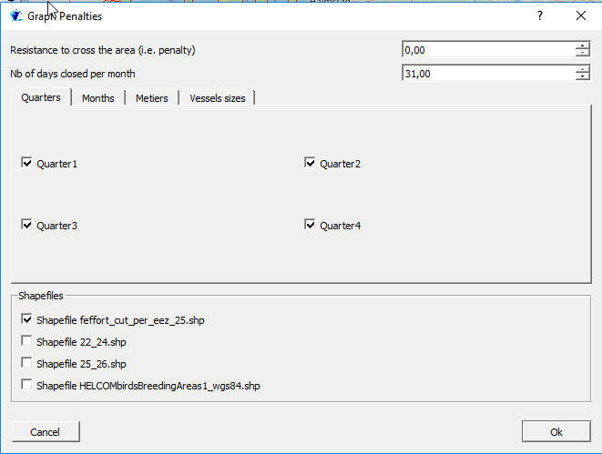

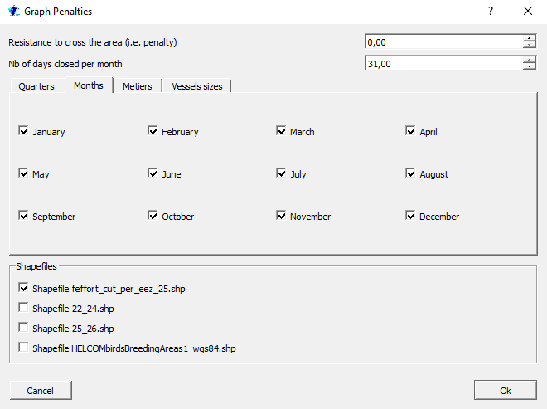Select the time restriction (here all months):

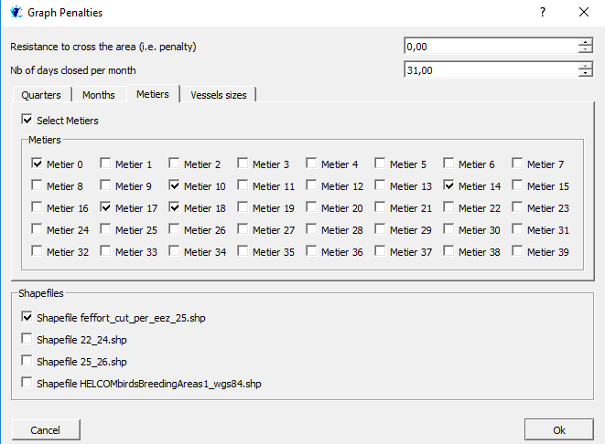Select the métiers (Here bottom-contact gears: 0; 10; 14; 17; 18):

Select the vessel size (here all sizes):

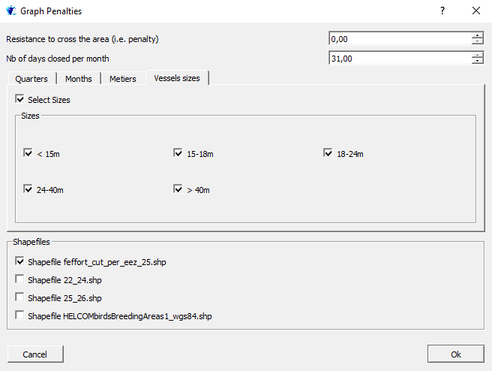

* 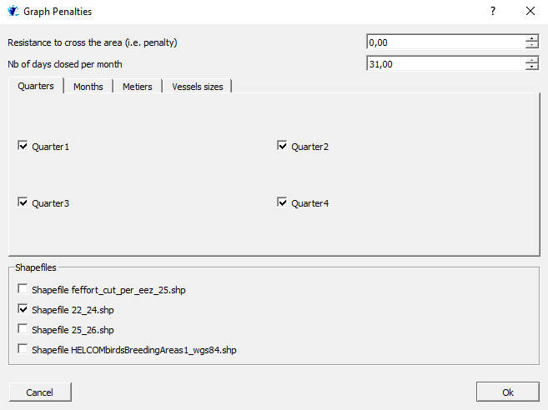**Scenario Western Baltic Cod (22_24)**

Select the time restriction, February and March for the WB:

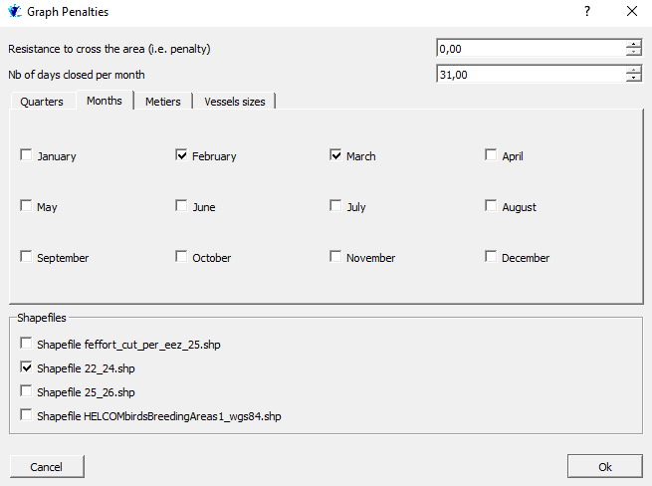

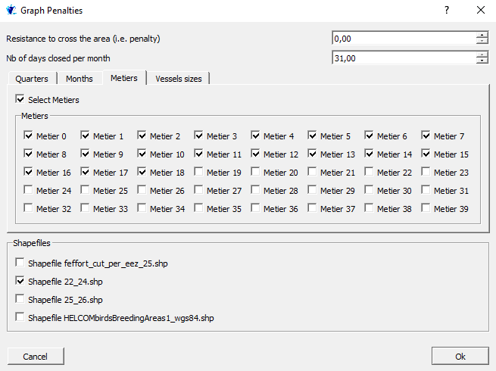Select the métiers, all the métiers for the WB (0:18):

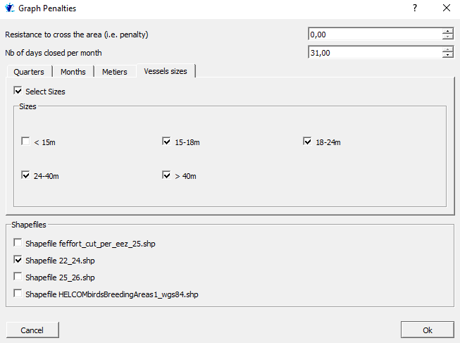Select the vessel size, more than 15m for the WB:

* **Scenario Eastern Baltic Cod (25_26):** just change of time restriction (July and August)

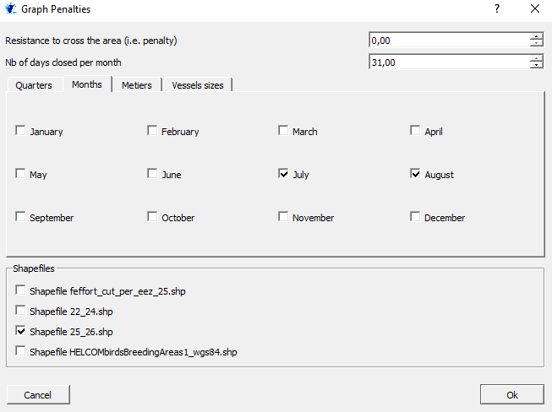

* **Scenario gillnetters restriction**

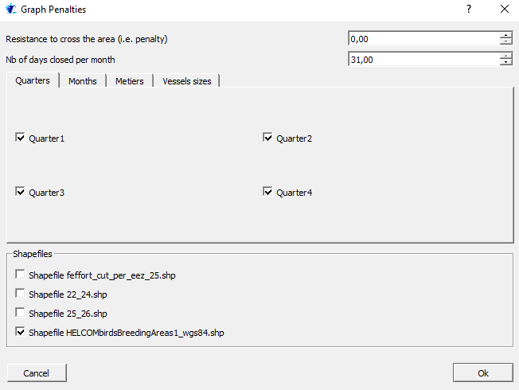

Select the time restriction (here all months)

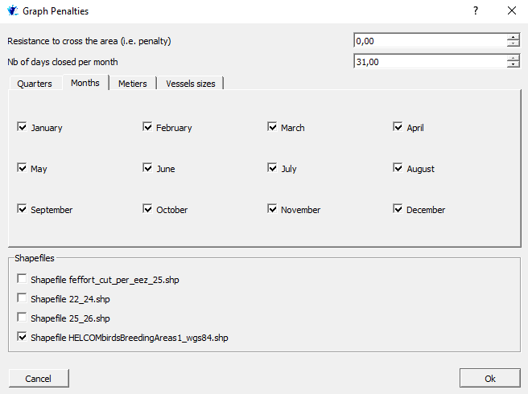

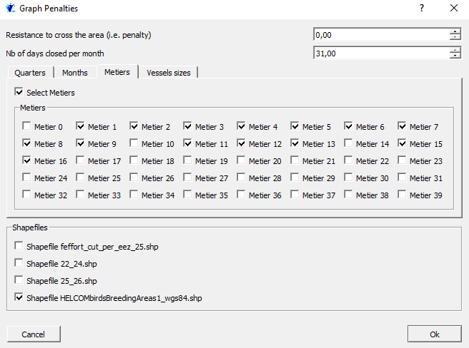Select the métiers (Here Netters: 1; 2; 3; 4; 5; 6; 7; 8; 9; 11; 12; 13; 15; 16):

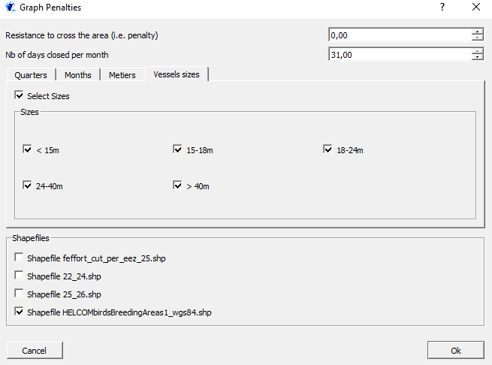Select the vessel size (here all sizes):